"Pickleball was created to be a fun, competitive, and highly social sport.
Since its inception, it has embodied an ethic of good sportsmanship that includes
respect, fair play, and graciousness in winning and losing."
Sportsmanship Guide | USA Pickleball

Taking time to review the USA Pickleball Rulebook will provide you with up-to-date rules to avoid confusion or conflict when playing in social, recreational, or organized leagues.

At the request of several of our members, we’d like to start reviewing rules that are often misunderstood or cause debate or confusion during open play and round robins. This month, our focus will be on LINE CALLS and when to call a ball in or out.

The images and passages below are taken directly from the USA Pickleball website and The Pickler.
Links are provided so you can review the information directly and in more detail.
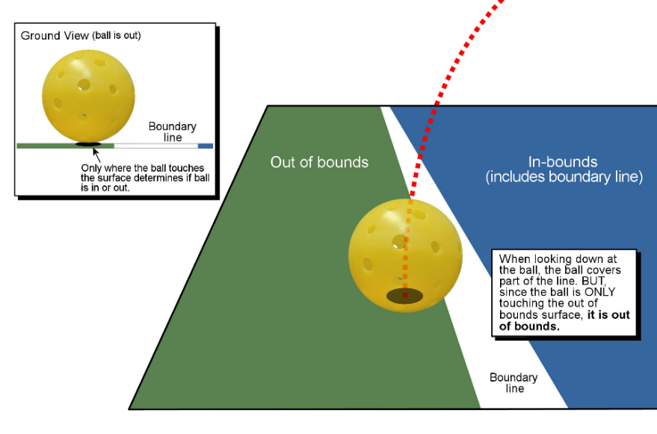

Image from https://usapickleball.org

From USA Pickleball Rulebook:
Players should only call a pickleball “out” when looking across a line on the pickleball court if they can clearly see space between the line and the space where the pickleball lands.

This means that close calls will be best viewed by a player that is looking from the inside of the pickleball line across the applicable line in question to the outside of the pickleball court, as opposed to a player that is on top of the line or looking from the outside of the pickleball court across the applicable line to the inside of the pickleball court. This is because the player looking from the inside of the court to the outside of the court will have the best angle to see whether there is space between the line and where the pickleball landed.

From The Pickler:
Players should call “out” balls promptly, which means that the “out” call should be before the opponent(s) hit the pickleball or the ball becomes dead. Players cannot wait until the end of a point or after a shot to make the appropriate call – the line call must be prompt. If an “out” call is not prompt, then the pickleball will be presumed to be “in” and the rally will be presumed to continue.

Voice and hand signals should be given to call “out” balls...regardless of how obvious the call may have been.
Players must give the benefit of any doubt on a line call to their opponent(s). In other words, if there was any uncertainty, the opponent(s) win the rally. All questionable line calls should be resolved in favor of the opponent(s).

If a doubles team disagrees on whether the pickleball was “in” or “out,” then the ball will be ruled “in.”

________________________________________
We hope you found this information helpful and encourage you to share it with others to provide clarity and promote good sportsmanship on the courts!

